NYMIR Risk Management Bulletin
Inflatable Equipment
June 2024

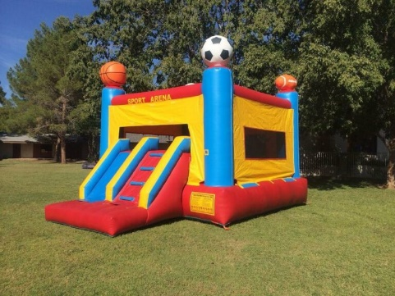
Inflatables (bounce houses) have become a very popular and frequent attraction at a variety of outside summer events. According to the U.S. Consumer Product Safety Commission (CPSC), between 2003 and 2013, there was a significant increase in the number of injuries from inflatable amusements. A 2020 study published in the journal *Pediatrics* found that from 2008 to 2017, there were approximately 92,000 injuries associated with inflatable amusements in the United States, with an average of about 9,200 injuries per year. These injuries primarily involved children and included fractures, sprains, and strains, with falls being the most common cause.
The following safety guidelines will help to ensure a safe “Fun Day”.

The most important safety factor when dealing with inflatables is the wind. Check with the rental firm providing the device for the maximum wind speed for safe operation of the inflatable device. Most manufacturers have a maximum rating of 15 miles per hour (MPH). Bounce equipment should come with a label containing safety information about set-up and assembly. Wind speeds above this rating require use of the device to be discontinued. As a point of reference – when treetops begin to sway – wind speeds are around 15 mph. On humid days, thunderstorms with wind gusts can “pop up” quickly – be alert for changing weather conditions and respond appropriately.

Please refer to U.S. Consumer Products Safety Commission bulletin on inflatable amusement rides. It can be accessed at:
https://www.cpsc.gov/Newsroom/News-Releases/2019/Dont-Get-Swept-Away-CPSC-Reminds-Consumers-to-Be-Grounded-in-Safety-When-Using-Bounce-Houses

Other safety tips for NYMIR subscribers:

- Select a reputable and properly insured rental firm. The rental firm should provide a certificate of insurance in accordance with your Risk Transfer Program. We recommend liability limits at a minimum of $1,000,000 each occurrence and $2,000,000 aggregate. Your municipality must be an additional insured. DO NOT SIGN A CONTRACT PRESENTED BY THE RENTAL COMPANY WITHOUT FIRST CONSULTING WITH YOUR ATTORNEY.
- The rental firm should review safe operating rules with someone during delivery and set up. They will generally require someone to sign off on the receipt of these rules. If something is not clear – ASK QUESTIONS! The rental firm will communicate a maximum number of individuals who can use the device at one time. Also ask about emergency procedures.
- Safety rules typically include prohibitions against food, drinks, gum, and pets on the equipment, climbing on the sides of the equipment, diving and summersaults. Removal of eyeglasses, hairclips, jewelry, and other sharp objects is required. DO NOT ALLOW A DEVICE TO BE OVERCROWDED!
- The rental firm supplying the inflatable must do the set up. They must secure the inflatable according to the manufacturer’s recommendations for the individual equipment. Inspect the inflatable and tie downs before and several times during use. If the inflatable tie downs become loose, the rental firm must be contacted immediately and use discontinued.
- Be consistent in terms of age and size for groups entering Bounce House. This helps to minimize miss-matches and reduce the potential for injury.
- There must be at least one person always supervising children in inflatables. Children must follow rules or be removed from the device.
- When inflated, watch for sagging, rips, or holes in the material.
- Ground Fault Circuit Interrupters must be used with outdoor extension cords. Try to locate electrical cords away from walkways to reduce the potential for a trip and fall.
- Isolate generators.
- Have fire extinguishers available if pump is gas powered.
- Set up away from overhead wires, traffic, and fences.
- Have radios or cell phones available to summon assistance should an emergency occur.

NYMIR
www.nymir.org
Karen Buckley, V.P Marketing
David Bloodgood, V.P. Risk Management
www.nymir.org

